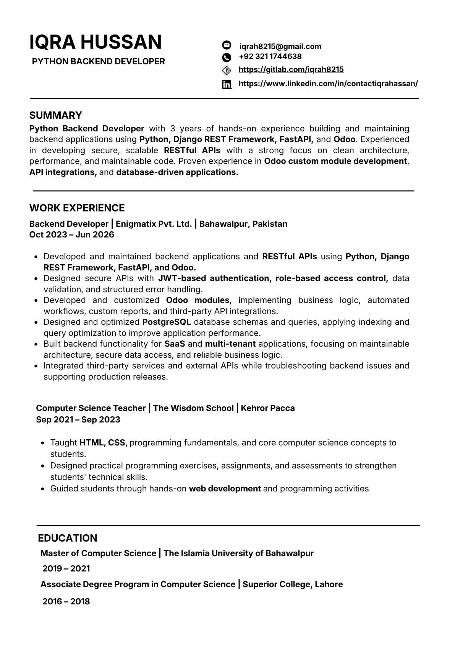
IQRA HUSSAN iqrah8215@gmail.com
+92 321 1744638
PYTHON BACKEND DEVELOPER
https://gitlab.com/iqrah8215
https://www.linkedin.com/in/contactiqrahassan/
SUMMARY
Python Backend Developer with 3 years of hands-on experience building and maintaining
backend applications using Python, Django REST Framework, FastAPI, and Odoo . Experienced
in developing secure, scalable RESTful APIs with a strong focus on clean architecture,
performance, and maintainable code. Proven experience in Odoo custom module development ,
API integrations, and database-driven applications.
WORK EXPERIENCE
Backend Developer | Enigmatix Pvt. Ltd. | Bahawalpur, Pakistan
Oct 2023 – Jun 2026
Developed and maintained backend applications and RESTful APIs using Python, Django
REST Framework, FastAPI, and Odoo.
Designed secure APIs with JWT-based authentication, role-based access control, data
validation, and structured error handling.
Developed and customized Odoo modules , implementing business logic, automated
workflows, custom reports, and third-party API integrations.
Designed and optimized PostgreSQL database schemas and queri es, applying indexing and
query optimization to improve application performance.
Built backend functionality for SaaS and multi-tenant a pplications, focusing on maintainable
architecture, secure data access, and reliable business logic.
Integ rated third-party services and external APIs while troubleshooting backend issues and
supporting production releases.
Computer Science Teacher | The Wisdom School | Kehror Pacca
Sep 2021 – Sep 2023
Taught HTML, CSS, programming fundamentals, and core computer science concepts to
students.
Designed practical programming exercises, assignments, and assessments to strengthen
students' technical skills.
Guided students through hands-on web development and programming activities
EDUCATION
Master of Computer Science | The Islamia University of Bahawalpur
2019 – 2021
Associate Degree Program in Computer Science | Superior College, Lahore
2016 – 2018

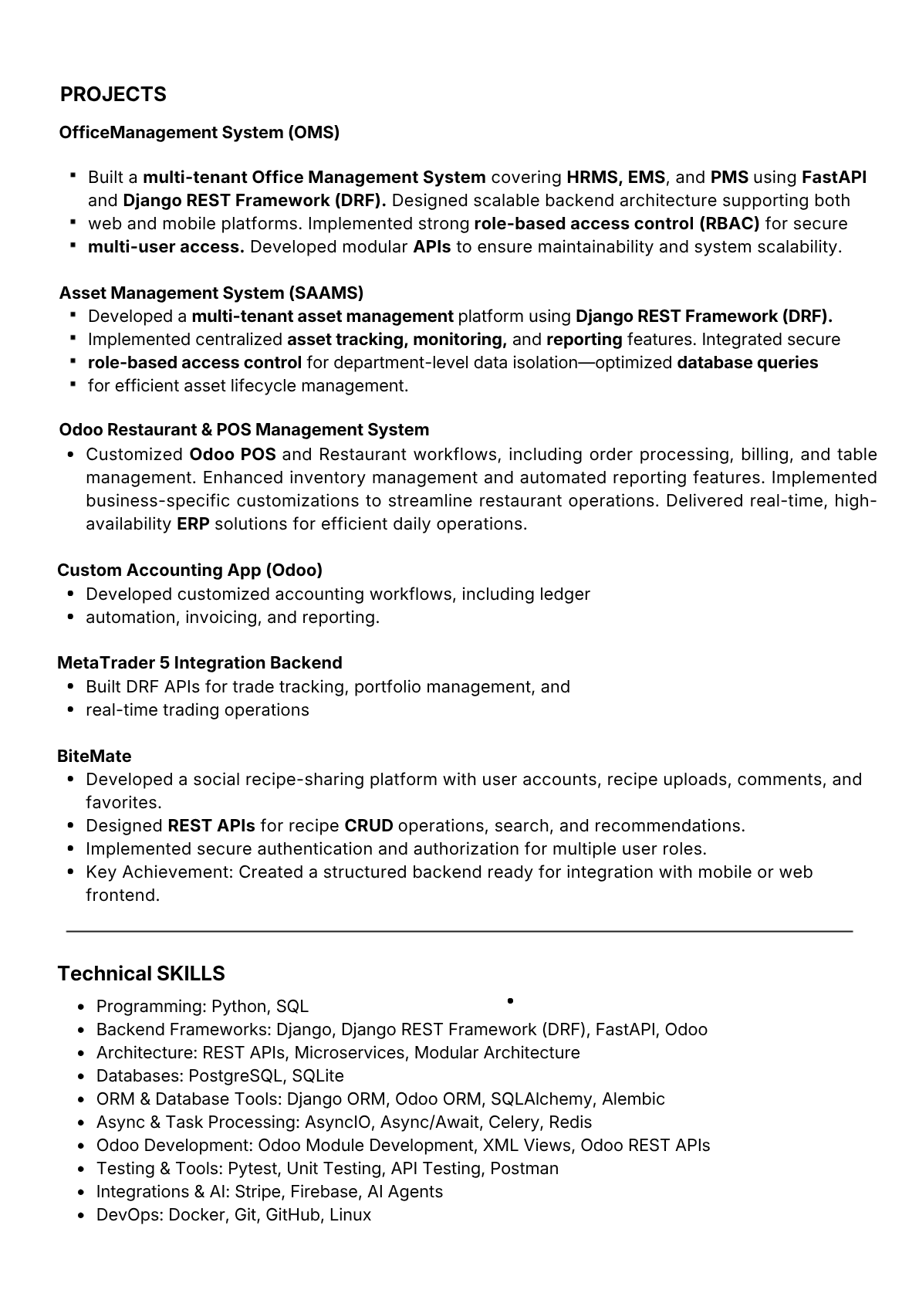
PROJECTS
OfficeManagement System (OMS)
Built a multi-tenant Office Management System covering HRMS, EMS , and PMS using FastAPI
and Django REST Framework (DRF). Designed scalable backend architecture supporting both
web and mobile platforms. Implemented strong role-based access control (RBAC) for secure
multi-user access. Developed modular APIs to ensure maintainability and system scalability.
Asset Management System (SAAMS)
Developed a multi-tenant asset management platform using Django REST Framework (DRF).
Implemented centralized asset tracking, monitoring, and reporting features. Integrated secure
role-based access control for department-level data isolation—optimized database queries
for efficient asset lifecycle management.
Odoo Restaurant & POS Management System
Customized Odoo POS and Restaurant workflows, including order processing, billing, and table
management. Enhanced inventory management and automated reporting features. Implemented
business-specific customizations to streamline restaurant operations. Delivered real-time, high-
availability ERP solutions for efficient daily operations.
Custom Accounting App (Odoo)
Developed customized accounting workflows, including ledger
automation, invoicing, and reporting.
MetaTrader 5 Integration Backend
Built DRF APIs for trade tracking, portfolio management, and
real-time trading operations
BiteMate
Developed a social recipe-sharing platform with user accounts, recipe uploads, comments, and
favorites.
Designed REST APIs for recipe CRUD operations, search, and recommendations.
Implemented secure authentication and authorization for multiple user roles.
Key Achievement: Created a structured backend ready for integration with mobile or web
frontend.
Technical SKILLS
Programming: Python, SQL
Backend Frameworks: Django, Django REST Framework (DRF), FastAPI, Odoo
Architecture: REST APIs, Microservices, Modular Architecture
Databases: PostgreSQL, SQLite
ORM & Database Tools: Django ORM, Odoo ORM, SQLAlchemy, Alembic
Async & Task Processing: AsyncIO, Async/Await, Celery, Redis
Odo o Development: Odoo Module Development, XML Views, Odoo REST APIs
Testing & Tools: Pytest, Unit Testing, API Testing, Postman
Integrations & AI: Stripe, Firebase, AI Agents
DevOps: Docker, Git, GitHub, Linux

